

Semester Two Examination, 2020

Question/Answer booklet

MATHEMATICS

SOLUTIONS
SPECIALIST
UNITS 1&2

Section One:

Calculator-free

WA student number: In figures

In words

Your name

Number of additional
answer booklets used
(if applicable):

Time allowed for this section
Reading time before commencing work: five minutes
Working time: fifty minutes

Materials required/recommended for this section
To be provided by the supervisor
This Question/Answer booklet
Formula sheet

To be provided by the candidate
Standard items: pens (blue/black preferred), pencils (including coloured), sharpener,
correction fluid/tape, eraser, ruler, highlighters

Special items: nil

Important note to candidates
No other items may be taken into the examination room. It is your responsibility to ensure that you do not have any unauthorised material. If you have any unauthorised material with you, hand it to the supervisor before reading any further.

Structure of this paper

Section | Number of  questions  available | Number of  questions to  be answered | Working  time  (minutes) | Marks  available | Percentage  of  examination
Section One:  Calculator-free | 8 | 8 | 50 | 52 | 35
Section Two:  Calculator-assumed | 13 | 13 | 100 | 98 | 65
 |  |  |  | Total | 100

Instructions to candidates

1. The rules for the conduct of examinations are detailed in the school handbook. Sitting this examination implies that you agree to abide by these rules.

2. Write your answers in this Question/Answer booklet preferably using a blue/black pen.
Do not use erasable or gel pens.

3. You must be careful to confine your answers to the specific question asked and to follow any instructions that are specific to a particular question.

4. Show all your working clearly. Your working should be in sufficient detail to allow your answers to be checked readily and for marks to be awarded for reasoning. Incorrect answers given without supporting reasoning cannot be allocated any marks. For any question or part question worth more than two marks, valid working or justification is required to receive full marks. If you repeat any question, ensure that you cancel the answer you do not wish to have marked.

5. It is recommended that you do not use pencil, except in diagrams.

6. Supplementary pages for planning/continuing your answers to questions are provided at the end of this Question/Answer booklet. If you use these pages to continue an answer, indicate at the original answer where the answer is continued, i.e. give the page number.

7. The Formula sheet is not to be handed in with your Question/Answer booklet.
Section One: Calculator-free 35% (52 Marks)
This section has eight questions. Answer all questions. Write your answers in the spaces provided.

Working time: 50 minutes.

Question 1 (7 marks)
Two matrices are $A=\left[\begin{matrix}-2 & 2 \\ -4 & 3\end{matrix}\right]$ and $B=\left[\begin{matrix}0 & -5 \\ 10 & 5\end{matrix}\right]$. Determine
Solution
$$3A-2B=\left[\begin{matrix}-6 & 6 \\ -12 & 9\end{matrix}\right]-\left[\begin{matrix}0 & -10 \\ 20 & 10\end{matrix}\right] \\ =\left[\begin{matrix}-6 & 16 \\ -32 & -1\end{matrix}\right]$$

Specific behaviours
one correct multiple
ü correct matrix

(a) $3A-2B$. (2 marks)

(b) $A^{-1}$. (2 marks)
Solution
$$\left|A\right|=\left(-2\right)\left(3\right)-\left(-4\right)\left(2\right)=2$$
$$A^{-1}=\frac{1}{2}\left[\begin{matrix}3 & -2 \\ 4 & -2\end{matrix}\right] \\ =\left[\begin{matrix}1.5 & -1 \\ 2 & -1\end{matrix}\right]$$

Specific behaviours
determinant
ü correct matrix

(c) $AB+B^{2}$. (3 marks)
Alternative Solution
$$AB=\left[\begin{matrix}20 & 20 \\ 30 & 35\end{matrix}\right] \\ B^{2}=\left[\begin{matrix}-50 & -25 \\ 50 & -25\end{matrix}\right] \\ AB+B^{2}=\left[\begin{matrix}-30 & -5 \\ 80 & 10\end{matrix}\right]$$

Specific behaviours
$AB$
ü $B^{2}$
ü correct matrix

Solution
$$\left(A+B\right)×B=\left[\begin{matrix}-2 & -3 \\ 6 & 8\end{matrix}\right]×\left[\begin{matrix}0 & -5 \\ 10 & 5\end{matrix}\right] \\ =\left[\begin{matrix}-30 & -5 \\ 80 & 10\end{matrix}\right]$$

Specific behaviours
factors
ü $A+B$
ü correct matrix

Question 2 (6 marks)
(a) State the exact value of $\cot{60°}$. (1 mark)
Solution
$$\frac{1}{\tan{60°}}=\frac{1}{\sqrt{3}}=\frac{\sqrt{3}}{3}$$

Specific behaviours
correct value

(b) Given that $\sec{θ}=\begin{matrix}3 \\ \overline{2}\end{matrix}$ and $-90°≤θ≤0°$, state the exact value of $\operatorname{cosec}{θ}$. (2 marks)
Solution
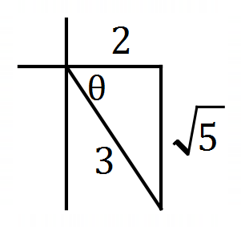
$$\operatorname{cosec}{θ}=\frac{3}{-\sqrt{5}}=-\frac{3\sqrt{5}}{5}$$

Specific behaviours
value is negative
ü correct value

(c) Sketch the graph of $y=2\sec{x}$ for $0°≤x≤180°$ on the axes below. (3 marks)

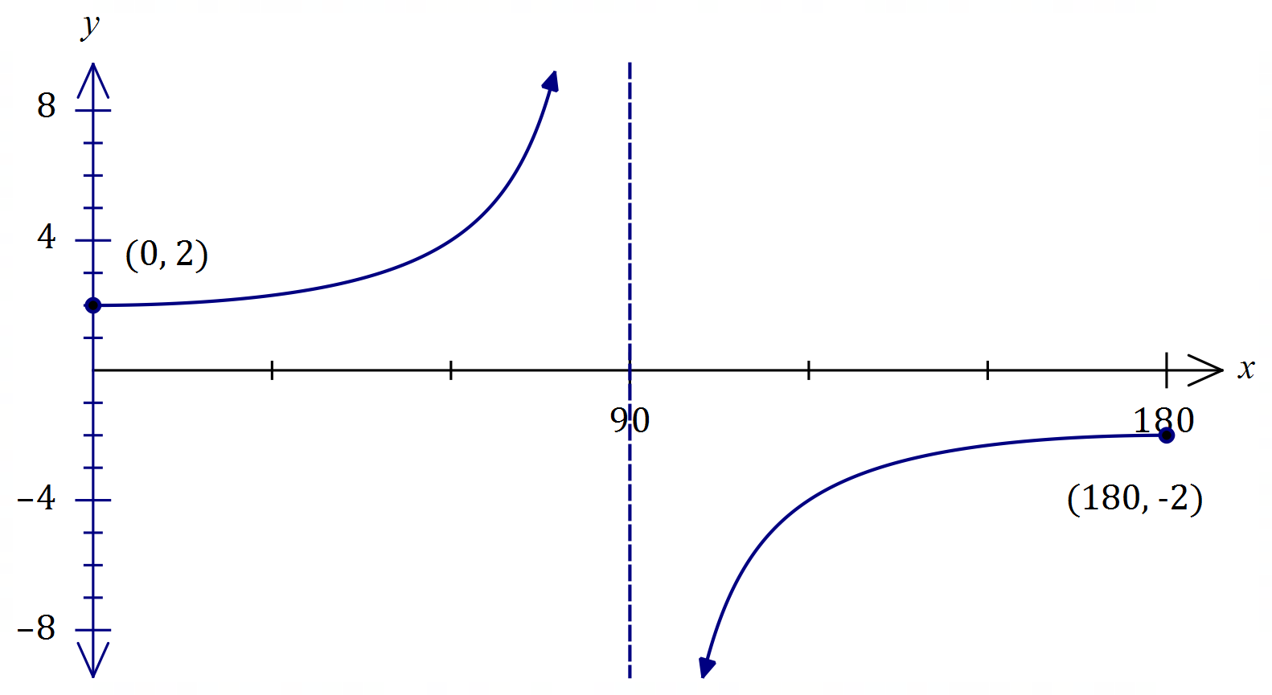
Solution
See graph
Specific behaviours
vertical asymptote
ü correct endpoints
ü smooth curves

Question 3 (8 marks)
(a) Express ${\left(\sqrt{5}+\sqrt{-5}\right)}^{2}$ in the form $a+bi$ where $a, b∈R$. (2 marks)
Solution
$$\left(\sqrt{5}+\sqrt{-5}\right)\left(\sqrt{5}+\sqrt{-5}\right)=5+2\sqrt{5}\sqrt{5}i-5 \\ =10i$$

Specific behaviours
uses $i^{2}=-1$
ü correctly simplifies

(b) Two complex numbers are $u=8+i$ and $v=2-i$. Calculate

(i) $u×v$. (1 mark)
Solution
$$uv=(8+i)(2-i) \\ =17-6i$$

Specific behaviours
correct product

(ii) $u÷v$. (2 marks)
Solution
$$\frac{u}{v}=\frac{8+i}{2-i}×\frac{2+i}{2+i} \\ =\frac{15+10i}{5} \\ =3+2i$$

Specific behaviours
correctly uses conjugate of $v$
ü correct quotient, simplified

(iii) $\operatorname{Im}{(2\overline{v}-iu)}$. (3 marks)
Solution
$$2\overline{v}=2\left(2+i\right)=4+2i$$

$$iu=i\left(8+i\right)=-1+8i$$

$$2\overline{v}-iu=5-6i⇒\operatorname{Im}\left(2\overline{v}-iu\right)=-6$$

Specific behaviours
$2\overline{v}$
ü product $iu$
ü imaginary part of difference

Question 4 (7 marks)
(a) Use an angle sum identity to prove that $\tan{2A}=\begin{matrix}2\tan{A} \\ \overline{1-\tan^{2}{A}}\end{matrix}$ . (2 marks)
Solution
$$\tan\left(A+A\right)=\frac{\tan{A}+\tan{A}}{1-\tan{A}\tan{A}} \\ \tan{2A}=\frac{2\tan{A}}{1-\tan^{2}{A}}$$

Specific behaviours
uses angle sum identity
ü simplifies

(b) Hence, or otherwise, prove that $\tan{3A}=\begin{matrix}3\tan{A}-\tan^{3}{A} \\ \overline{ 1-3\tan^{2}{A} }\end{matrix}$ . (3 marks)
Solution
$$\tan\left(2A+A\right)=\frac{\tan{2A}+\tan{A}}{1-\tan{2A}\tan{A}} \\ \tan{3A}=\frac{\frac{2\tan{A}}{1-\tan^{2}{A}}+\tan{A}}{1-\frac{2\tan{A}}{1-\tan^{2}{A}}×\tan{A}} \\ =\frac{2\tan{A}+\tan{A}-\tan^{3}{A}}{1-\tan^{2}{A}-2\tan^{2}{A}} \\ =\frac{3\tan{A}-\tan^{3}{A}}{1-3\tan^{2}{A}}$$

Specific behaviours
uses angle sum identity
ü uses double angle identity
ü simplifies

(c) Solve $3\tan{A}-\tan^{3}{A}=1-3\tan^{2}{A}$ for $0°<A<30°$. (2 marks)
Solution
$$\frac{3\tan{A}-\tan^{3}{A}}{1-3\tan^{2}{A}}=1 \\ \tan{3A}=1 \\ A=15°$$

Specific behaviours
writes equation using triple angle
ü correct solution

Question 5 (5 marks)
$AC$ is a diameter of a circle centre $O$ and point $B$ lies on the circumference of the circle.
Let $\vec{OA}=a$ and $\vec{OB}=b$.
Use a vector method to prove that $∠ABC=90°$.
Solution
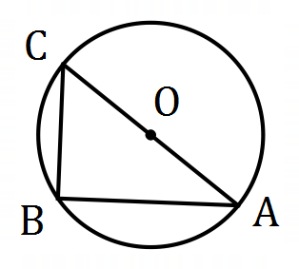

$$\vec{AB}=b-a, \vec{CB}=a+b$$

$$\vec{CB}∙\vec{AB}=\left(a+b\right)∙\left(b-a\right) \\ =a∙b-a∙a+b∙b-b∙a \\ ={\left|b\right|}^{2}-{\left|a\right|}^{2} \\ =0 (\left|a\right|=\left|b\right|=\text{radius})$$

Hence $\vec{AB}$ and $\vec{CB}$ are perpendicular ($∠ABC=90°$) since their magnitudes are not zero yet the scalar product is zero.

Specific behaviours
ü labelled sketch
vectors $\vec{AB}$ and $\vec{CB}$
ü forms scalar product
ü simplifies
ü explains result

Question 6 (6 marks)
(a) Determine the equation of the real quadratic $f(z)$ in the form $z^{2}+az+b$ given that $f\left(5-3i\right)=0$. (2 marks)
Alternative Solution
$$a=-2\left(5\right)=-10$$
$$b=5^{2}+3^{2}=34$$
$$f\left(z\right)=z^{2}-10z+34$$

Specific behaviours
shows sum and product of roots
ü correct equation

Solution
$$f\left(z\right)=\left(z-5+3i\right)\left(z-5-3i\right) \\ =z^{2}-10z+34$$

Specific behaviours
shows product of linear factors
ü correct equation

(b) Let $g\left(z\right)=z^{2}-8z+17$.

(i) Determine $z_{1}$ and $z_{2}$, the complex roots of $g$. (2 marks)
Solution
$${\left(z-4\right)}^{2}=-17+4^{2} \\ =-1=i^{2} \\ z=4±i$$
$$z_{1}=4+i, z_{2}=4-i$$

Specific behaviours
indicates suitable method
ü correct conjugate roots

(ii) Sketch and label $z_{1}$, $z_{2}$ and $w=z_{1}+z_{2}$ in the complex plane below. (2 marks)

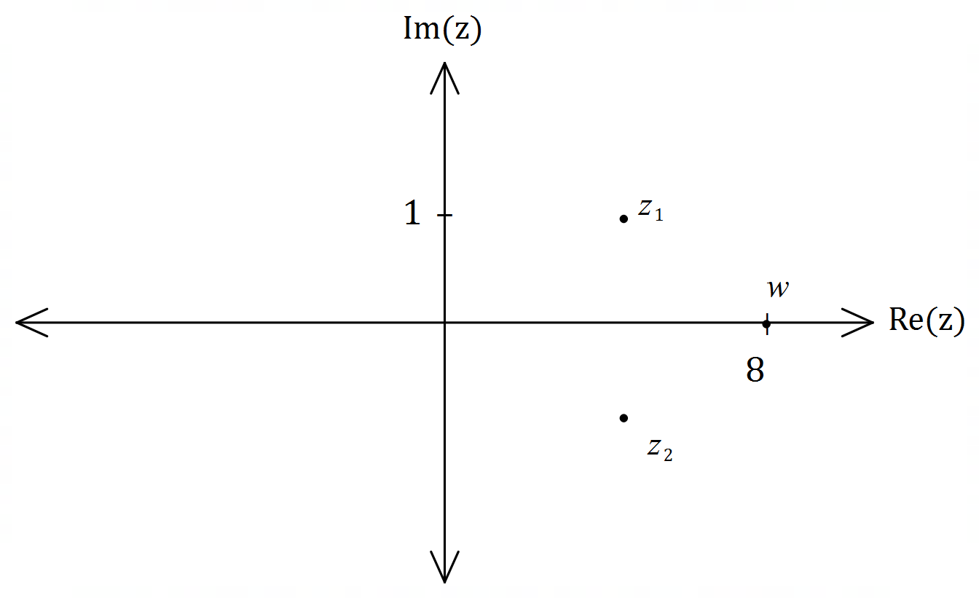
Solution
See graph (their $z_{1}$ and $z_{2}$)
Specific behaviours
roots clearly conjugate pair
ü scales axes and locates $w$

Question 7 (7 marks)
Use mathematical induction to prove the following proposition $P(n)$ for every integer $n≥0$.

$$P\left(n\right): 1+9+17+25+…+\left(8n+1\right)=(n+1)(4n+1)$$
Solution
1. When $n=0$:
$$P\left(0\right):8\left(0\right)+1=\left(0+1\right)\left(4\left(0\right)+1\right)→1=1, ∴\text{true}$$

2. Assume $P(k)$ is true:
$$1+9+…+\left(8k+1\right)=(k+1)(4k+1)$$

3. Now required to prove $P(k+1)$:
$$1+9+…+\left(8k+1\right)+\left(8\left(k+1\right)+1\right)=\left(\left(k+1\right)+1\right)\left(4\left(k+1\right)+1\right) \\ =(k+2)(4k+5)$$

From assumption:
$$1+9+…+\left(8k+1\right)=(k+1)(4k+1)$$
Hence
$$1+9+…+\left(8k+1\right)+\left(8\left(k+1\right)+1\right)=(k+1)(4k+1)+\left(8\left(k+1\right)+1\right) \\ =4k^{2}+5k+1+8k+9 \\ =4k^{2}+13k+10 \\ =(k+2)(4k+5)$$

Since $P(0)$ is true and we have shown that $P(k+1)$ is true if $P(k)$ is true then $P(n)$ is true for all integers $n≥0$.

Specific behaviours
shows true for $n=0$
ü states assumption that $P(k)$ is true
ü indicates expression required for $P(k+1)$
ü adds ${\left(k+1\right)}^{th}$ term to assumption
ü expands RHS
ü factors RHS
ü uses principle of mathematical induction

Question 8 (6 marks)
(a) Determine the vector projection of $2i-j$ on $-3i+4j$. (2 marks)
Solution
$$\left(\frac{1}{5}\left(\begin{matrix}-3 \\ 4\end{matrix}\right)∙\left(\begin{matrix}2 \\ -1\end{matrix}\right)\right)\frac{1}{5}\left(\begin{matrix}-3 \\ 4\end{matrix}\right)=\frac{-10}{25}\left(\begin{matrix}-3 \\ 4\end{matrix}\right) \\ =\left(\begin{matrix}6/5 \\ -8/5\end{matrix}\right)$$

Specific behaviours
indicates method
ü correct projection

Alternative Solution
$$\frac{\left(\begin{matrix}2 \\ -1\end{matrix}\right)∙\left(\begin{matrix}-3 \\ 4\end{matrix}\right)}{\left(\begin{matrix}-3 \\ 4\end{matrix}\right)∙\left(\begin{matrix}-3 \\ 4\end{matrix}\right)}\left(\begin{matrix}-3 \\ 4\end{matrix}\right)=\frac{-10}{25}\left(\begin{matrix}-3 \\ 4\end{matrix}\right) \\ =\left(\begin{matrix}6/5 \\ -8/5\end{matrix}\right)$$

Specific behaviours
indicates method
ü correct projection

(b) The vectors $ai+j$ and $4i+bj$ are perpendicular and the sum of their magnitudes is $10$. Determine the values of the constants $a$ and $b$. (4 marks)
Solution
Perpendicular: $4a+b=0$.
Magnitudes: $\sqrt{a^{2}+1}+\sqrt{{16+b}^{2}}=10$.
Hence
$$b=-4a⇒b^{2}=16a^{2} \\ \sqrt{a^{2}+1}+\sqrt{{16+16a}^{2}}=10 \\ \sqrt{a^{2}+1}+4\sqrt{a^{2}+1}=10 \\ \sqrt{a^{2}+1}=2 \\ a^{2}=3⇒a=±\sqrt{3} \\ b=∓4\sqrt{3}$$
Hence $a=\sqrt{3}, b=-4\sqrt{3}$ or $a=-\sqrt{3}, b=4\sqrt{3}$.

Specific behaviours
two equations
ü eliminates one variable
ü solves for one variable
ü clearly states both solutions

Supplementary page

Question number: _________

© 2020 WA Exam Papers. Kennedy Baptist College has a non-exclusive licence to copy and communicate this document for non-commercial, educational use within the school. No other copying, communication or use is permitted without the express written permission of WA Exam Papers. SN245-161-3.

